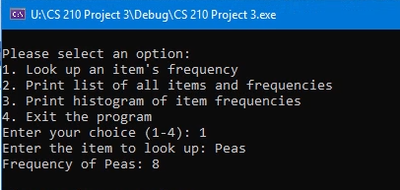

The main menu shows 4 options that the user can select: 1, 2, 3, and 4. The first option, option 1, looks up the items frequency by searching the name of the item. The picture above shows that the user selected the option 1 by typing “1”. This then brought up the prompt asking for the item in question. In this case, the user input the word “Peas”, and the program gave the frequency output showing that there are a frequency of 8 Peas.

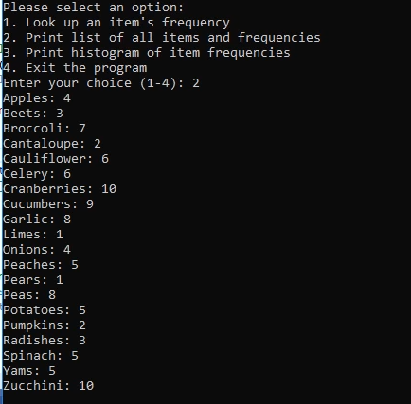

The second option works in a similar manner as shown above. In this example, the user gave the input for option 2. The program then output a list of all items and the frequency of each item.

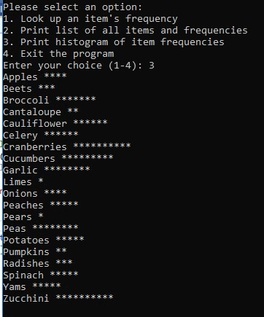

For the third option as shown above, the user input the number three when prompted. The program then gave the output of a histogram. This histogram shows the names of the item and uses symbols to visualize the item count.

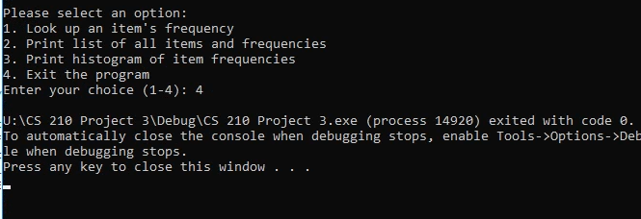

The fourth and final option, as shown above, is an option to exit the program. When the user inputs the number 4, the program then ends and the user is told to press any key to close the window. The program will loop until the exit input is used. This allows the user to select and view all outputs without the program ending after one action.